**National Textile University**

**Department of Computer Science**

**Subject: Operating System**

**Submitted to: Nasir Mahmood**

**Submitted by: Eemaan Fatima**

**Reg number:23-NTU-CS-1146**

**Assignment No.4**

**Semester:5th**

**Lab manual 04**

**Task 1:**

**Code :**

 #include <stdio.h>

 #include <pthread.h>

 #include <unistd.h>

 // Thread function - this will run in the new thread

 void* thread_function(void* arg) {

 printf("Hello from the new thread!\n");

 printf("Thread ID: %lu\n", pthread_self());

 return NULL;

 }

 int main() {

 pthread_t thread_id;

 printf("Main thread starting...\n");

 printf("Main Thread ID: %lu\n", pthread_self());

 // Create a new thread

 pthread_create(&thread_id, NULL, thread_function, NULL);

// Wait for the thread to finish

 pthread_join(thread_id, NULL);

 printf("Main thread exiting...\n");

 return 0;

 }

**Remarks :**

* The main program starts and prints its own ID.
* Then it creates a new thread.
* The new thread runs the thread_function, prints its message and its own ID.
* The main program waits for the new thread to finish, then prints “Main thread exiting.

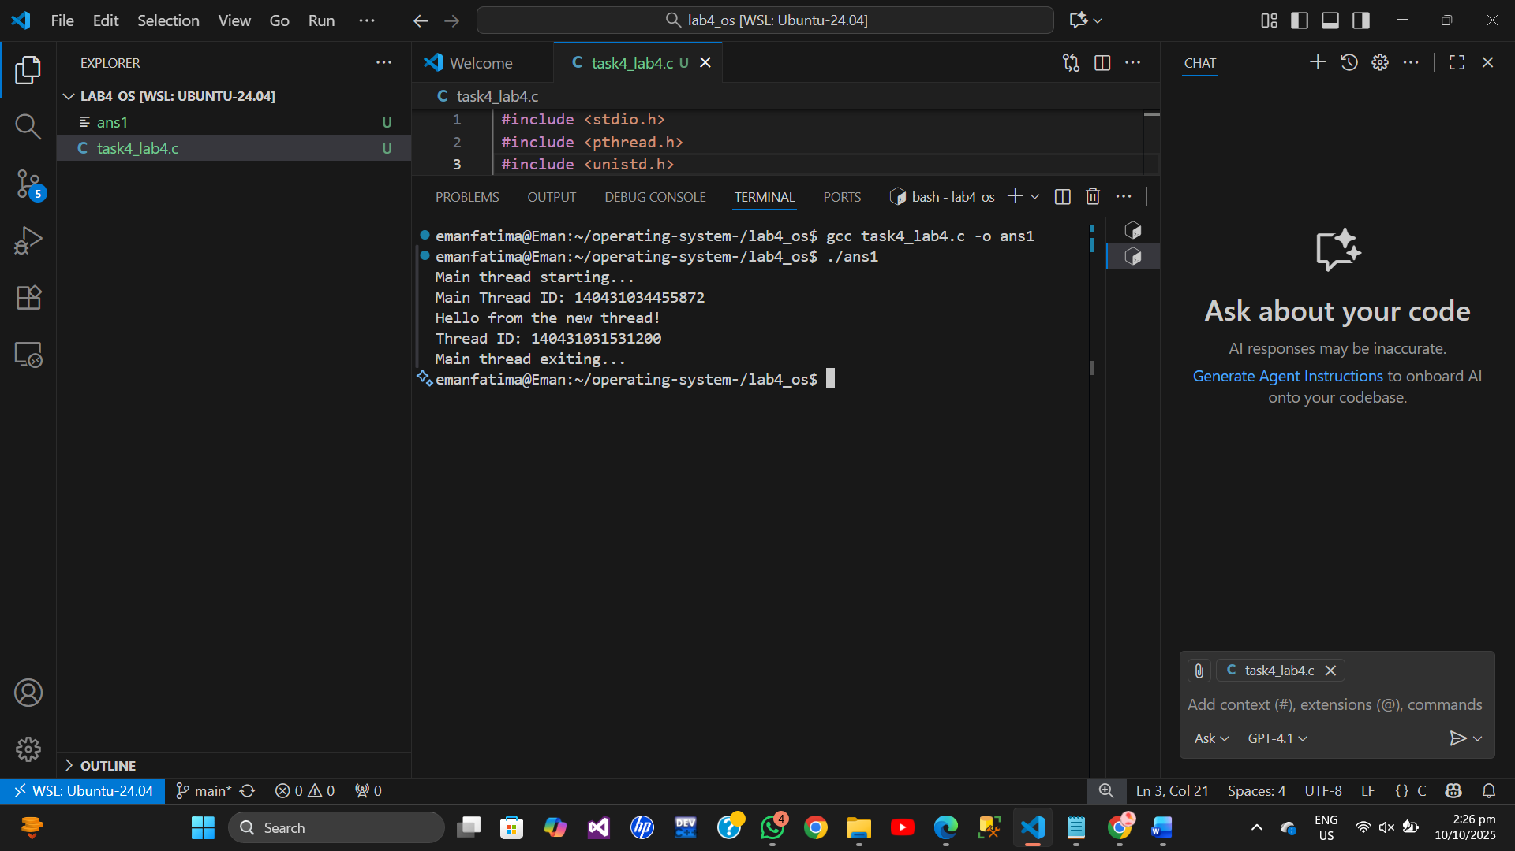

**Task 2:**

**Code :**

 #include <stdio.h>

 #include <pthread.h>

 void* print_number(void* arg) {

// We know that we've passed an integer pointer

 int num = *(int*)arg; // Cast void* back to int*

 printf("Thread received number: %d\n", num);

 printf("Square: %d\n", num * num);

 return NULL;

 }

 int main() {

 pthread_t thread_id;

 int number = 42;

 printf("Creating thread with argument: %d\n", number);

 // Pass address of 'number' to thread

 pthread_create(&thread_id, NULL, print_number, &number);

 pthread_join(thread_id, NULL);

 printf("Main thread done.\n");

 return 0;

 }

**Remarks :**

* **In this program, the main function is running, and a number 42 is created.**
* **Then, a new thread is created.**
* **A thread function is defined, and this number is passed to the thread as an argument (by passing the address of the variable number).**
* **Inside the thread function, the argument is received as a void* pointer.**
* **To use it as an integer, it is typecast back to an int using *(int*)arg.**
* **Then, the thread prints the received number and its square.**
* **Finally, the main program waits for the thread to finish before printing “Main thread done.”**

